# Link

* <https://www.youtube.com/watch?v=2wVjt3yhGwg>

# Time Complexity

* + O(N)

# Tricks

* Array must be sorted some way
* While Loop start < end
* When to move/increment Start Index
  + When Sum is less than TARGET
* When to move/decrement End Index
  + When Sum is greater than TARGET

# Overview of Two pointer

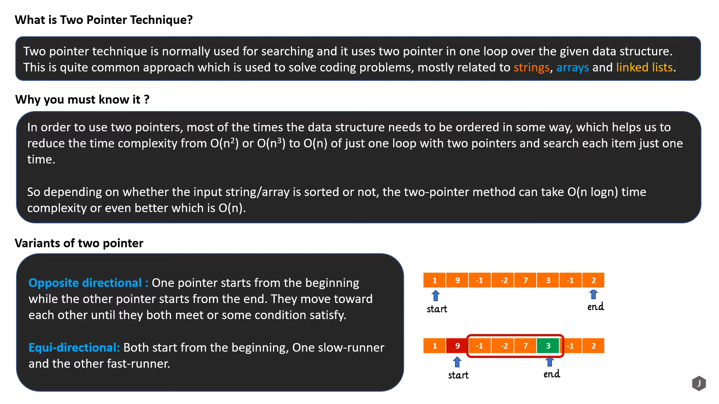

# Problem based on two pointer

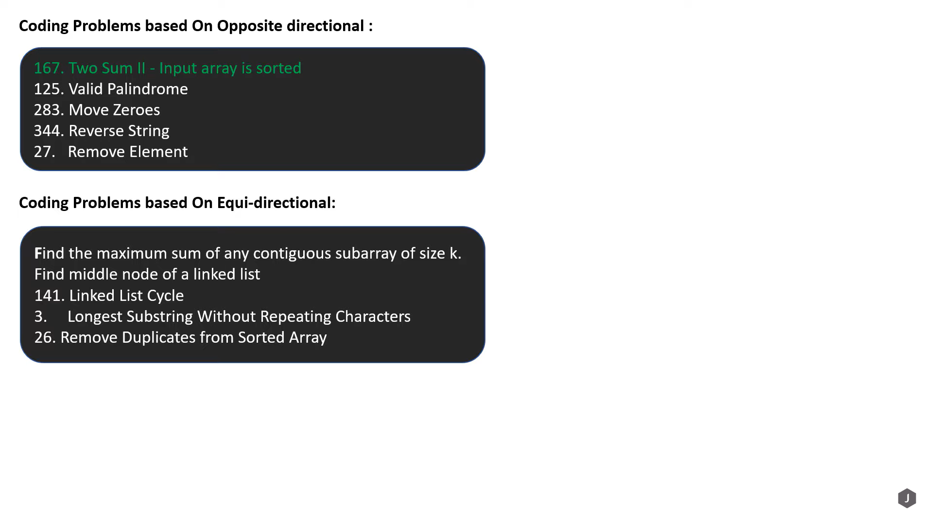

# Opposite directional approach

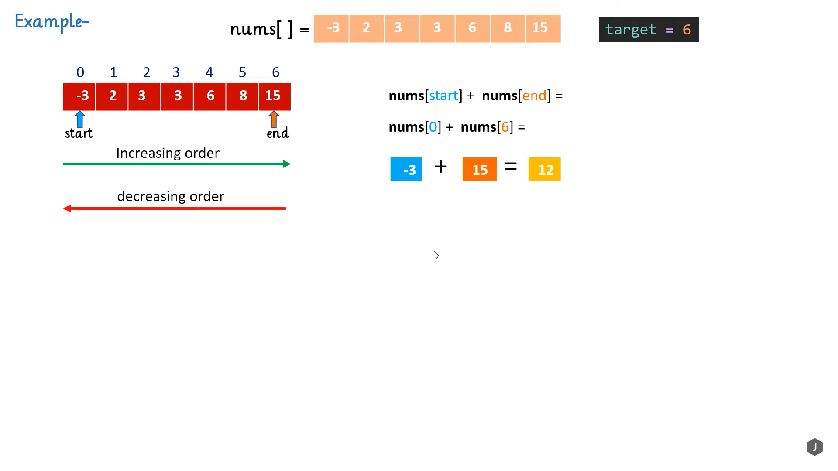

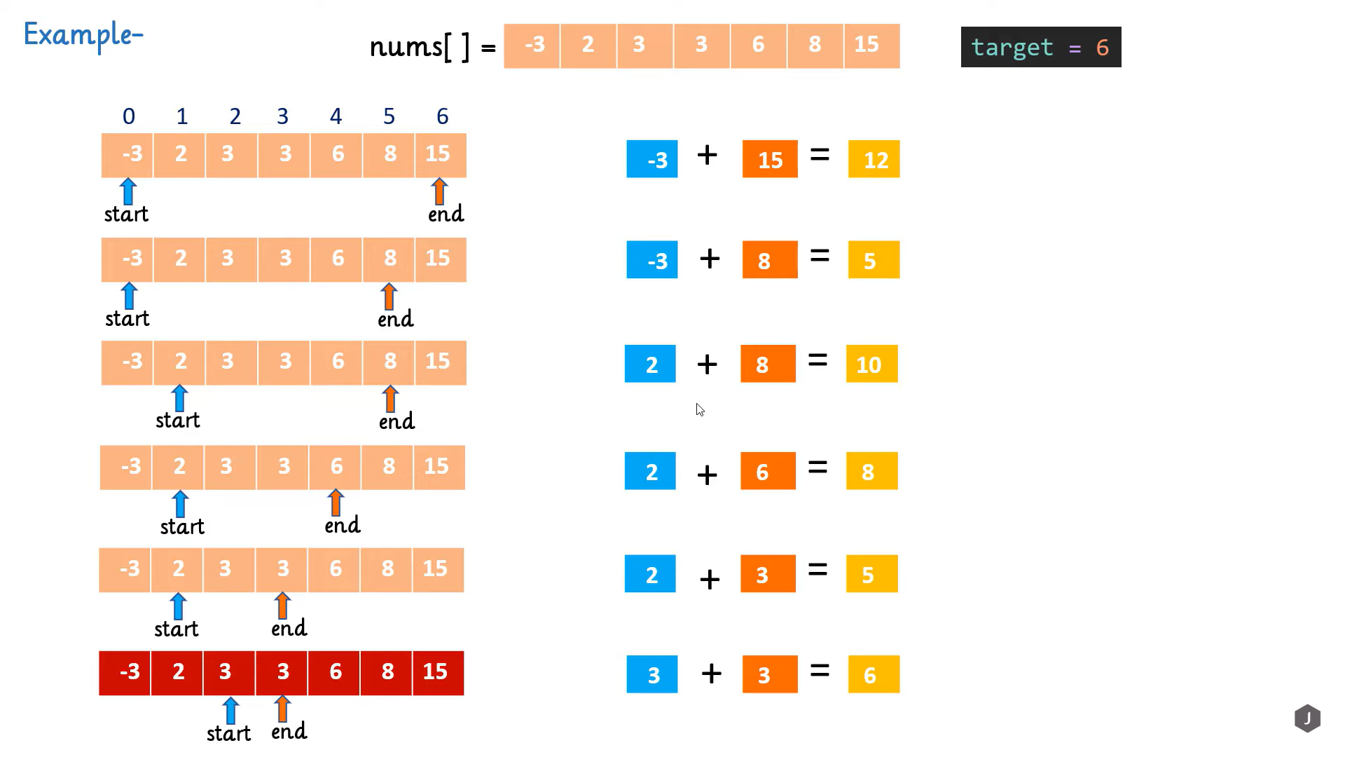

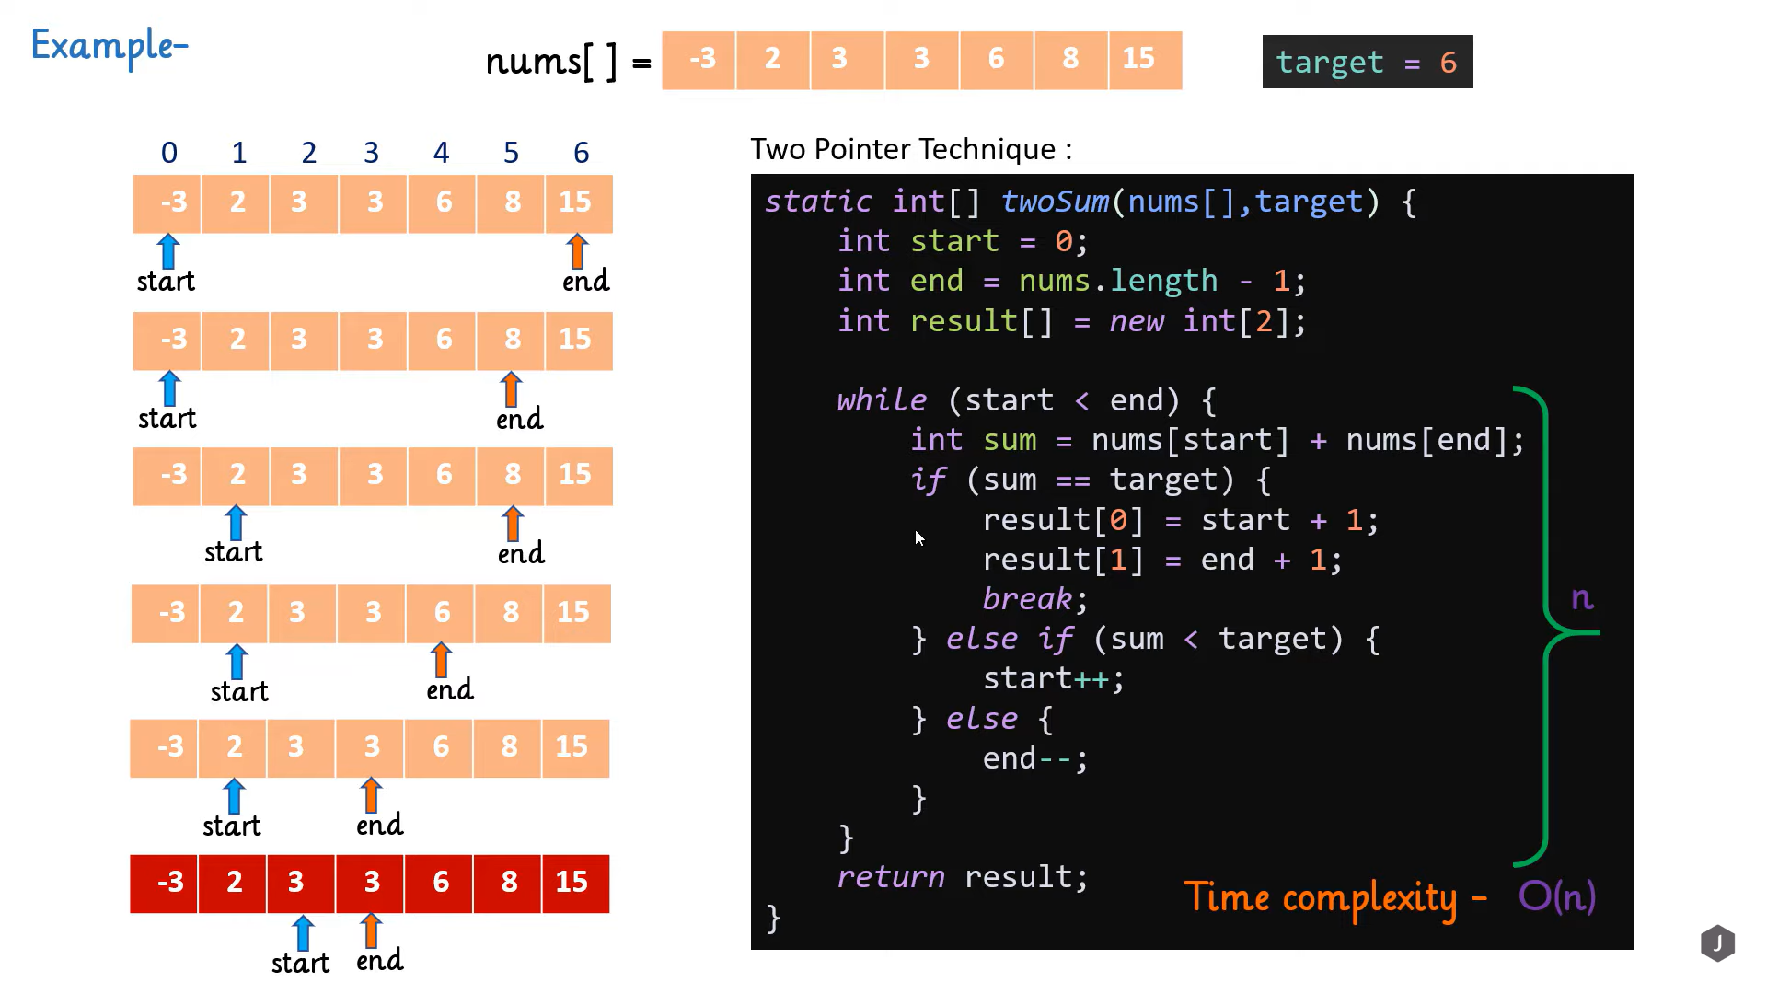

# Equi- directional approach -can be achieved using sliding window

